Draft Environmental Assessment for the Replacement of the Administrative Building Complex and Construction
of the Next Big Thing Experience at the
John F. Kennedy Space Center, Florida

December 2023

National Aeronautics and Space Administration John F. Kennedy Space Center, Florida
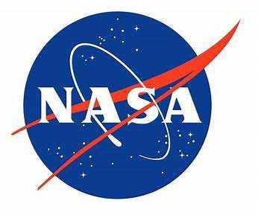

Prepared for:
Delaware North

ENVIRONMENTAL ASSESSMENT
for THE REPLACEMENT OF THE ADMINISTRATIVE
BUILDING COMPLEX AND CONSTRUCTION OF THE
Next Big Thing Experience AT THE
JOHN F. KENNEDY SPACE CENTER, florida

Abstract

This Environmental Assessment (EA) evaluates the environmental effects of the proposed replacement of the existing Administrative Building Complex and construction of the Next Big Thing (NBT) experience at the existing Kennedy Space Center (KSC) Visitor Complex (VC) site. Under the Proposed Action, the Administrative Building Complex would be relocated to the existing Parking Lot 2 footprint, the existing Administrative Building Complex would be demolished, the existing retail warehouse would be demolished, the two trailers south of the existing Administrative Building Complex would be demolished or removed, and the NBT experience would be constructed at the former Administrative Building Complex site. The VC is south of NASA Causeway at KSC.
The purpose of the Proposed Action is to modernize the Administrative Building Complex used by VC support employees for offices, restrooms, break areas, and utility and storage areas. The purpose of the new NBT experience would be to attract additional visitors and immerse them in a uniquely themed, enhanced interactive environment of National Aeronautics and Space Administration’s (NASA’s) past and future. The Proposed Action is needed to provide visitors with continued access to NASA’s history through educational programs, attractions, and other similar experiences consistent with the KSC Master Plan and existing concession agreement between Delaware North Parks & Resorts and KSC.
This EA evaluates the potential environmental effects associated with the No Action Alternative and the Proposed Action (Preferred Alternative) and includes the following resource categories: transportation, utilities, cultural resources, and socioeconomics.
Environmental effects from the Proposed Action and No Action Alternatives were classified as none, negligible, or minor. Under the No Action Alternative, the modernized Administrative Building Complex and new NBT experience would not be constructed; the No Action Alternative would result in no effects to the environment. The No Action Alternative was not selected because this alternative does not meet the purpose and need of the Proposed Action; however, the No Action Alternative was carried forward for analysis in the EA for the purposes of analyzing the consequences of not undertaking the Proposed Action and establishing a comparative environmental baseline.
The construction portion of the Proposed Action would result in no effects to cultural resources, negligible to minor adverse effects to utilities, minor adverse effects to transportation, and minor beneficial effects to socioeconomics. Further, operation of the Proposed Action would result in no effects to cultural resources, negligible adverse effects to transportation and utilities, and minor beneficial effects to socioeconomics.
LEAD AGENCY: National Aeronautics and Space Administration
John F. Kennedy Space Center
Environmental Program Office
Kennedy Space Center, FL 32899

POINT OF CONTACT: James Brooks
Environmental Planning
Mail Code S1-E3
Kennedy Space Center, FL 32899
(321) 867-9081
james.t.brooks-1@nasa.gov

Table of Contents

EXECUTIVE SUMMARY 1
1.0 PURPOSE OF AND NEED FOR THE PROPOSED ACTION 3
1.1 Introduction 3
1.2 Background 3
1.3 Location 3
1.4 Purpose of and Need for the Proposed Action 4
1.5 Decision to be Made 8
1.6 Lead and Cooperating Agencies 8
2.0 DESCRIPTION OF PROPOSED ACTION AND ALTERNATIVES 9
2.1 Proposed Action 9
2.2 Screening Factors 11
2.3 Alternatives Carried Forward for Analysis 12
2.3.1 No Action Alternative 12
2.3.2 Proposed Action (Preferred Alternative) – Replace Existing Administrative Building Complex and Construct the NBT Experience 12
2.4 Alternatives Considered But Not Carried Forward to Detailed Analysis 13
2.5 Best Management Practices Included in the Proposed Action 13
3.0 Affected Environment and Environmental Consequences 16
3.1 Resource Categories Not Carried Forward for Detailed Analysis 16
3.2 Resource Categories Carried Forward for Detailed Analysis 19
3.2.1 Transportation 19
3.2.2 Utilities 22
3.2.3 Cultural Resources 24
3.2.4 Socioeconomics 29
4.0 CUMULATIVE EFFECTS 31
4.1 Definition of Cumulative Effects 31
4.2 Scope of Cumulative Effects Analysis 31
4.3 Past, Present, and Reasonably Foreseeable Actions 32
4.3.1 Widening of Space Commerce Way (2023–2025) 32
4.3.2 KSC VC 15-Year Development Plan (2025 – 2040) 33
4.4 Cumulative Effect Analysis 33
4.4.1 Transportation 33
4.4.2 Utilities 33
4.4.3 Wastewater System 35
4.4.4 Water System 35
4.4.5 Power Supply 36
4.4.6 Cultural Resources 36
4.4.7 Socioeconomics 36
5.0 PREPARERS, CONTRIBUTORS, AND CONTACTS 39
6.0 LITERATURE CITED 41

LIST OF FIGURES
Figure 1-1 Regional Location Map 5
Figure 1-2 Aerial Location Map 6
Figure 1-3 KSC Visitor Complex General Site Layout Map 7
Figure 2-1 Conceptual Plan View Map of the Proposed Administrative Building
Complex 10
Figure 3-1 Transportation Map 21
Figure 3-2 c.1960 USGS Topographic Location Map, Orsino, Florida, Showing APEs in Ponded Wetlands 26
Figure 3-3 c.1943 Aerial Photograph, Flight 2C, Showing APEs in Ponded Wetlands 27
Figure 3-4 c.1976 USGS Topographic Location Map, Orsino, Florida, Showing VC Experience in Previously Disturbed Area 27
Figure 3-5 c.1969 Aerial Photograph, Flight 1KK, Showing VC Experience in Previously Disturbed Area 28
Figure 4-1 Space Commerce Way Widening Project Area 32
Figure 4-2 Proposed 15-Year KSC VC Development Plan 34

LIST OF TABLES
Table 2-1 Best Management Practices 14
Table 3-1 Summary of Potential Environmental Effects 16
Table 3-2 Daily Traffic Counts by Road Segment 20
Table 5-1 List of Individuals Who Prepared This Document 39

LIST OF APPENDICES
Appendix A: Record of Environmental Consideration
Appendix B: October 2023 Structures Survey Letter Report and Section 106 Correspondence

List of Abbreviations and Acronyms

AADF | Annual Average Daily Flow
AADT | Average Annual Daily Traffic
APE | Area of Potential Effect
ARPA | Archaeological Resource Protection Act
BMP | Best Management Practice(s)
CCSFS | Cape Canaveral Space Force Station
CEQ | Council on Environmental Quality
CFR | Code of Federal Regulations
cm | centimeter(s)
EA | Environmental Assessment
ERP | Environmental Resource Permit
FDEP | Florida Department of Environmental Protection
FDOT | Florida Department of Transportation
FPL | Florida Power & Light
FY | Fiscal Year
gsf | Gross Square Feet
HVAC | Heating, Ventilation, and Air-Conditioning
ICRMP | Integrated Cultural Resources Management Plan
IRL | Indian River Lagoon
km | Kilometer
km² | Square Kilometers
KSC | Kennedy Space Center
kV | kilovolt
kVA | kilovolt-amp
m² | Square Meters
NAAQS | National Ambient Air Quality Standards
NAGPRA | Native American Graves and Repatriation Act
NASA | National Aeronautics and Space Administration
NBT | Next Big Thing
NEPA | National Environmental Policy Act
NHPA | National Historic Preservation Act
NPDES | National Pollutant Discharge Elimination System
NPR | NASA Procedural Requirement
NRHP | National Register of Historic Places
O₃ | Ozone
PEA | Programmatic Environmental Assessment
PM_{2.5} | Particulate Matter 2.5 Micrometers or less in Diameter
RWWTF | Regional Wastewater Treatment Facility
SJRWMD | St. Johns River Water Management District
SLD | Space Launch Delta
SR | State Road
SWPPP | Stormwater Pollution Prevention Plan
TCP | Traditional Cultural Properties
USC | U.S. Code
USEPA | U.S. Environmental Protection Agency
USGS | U.S. Geological Survey
VC | Visitor Complex
WWTF | Wastewater Treatment Facility
ZAP | Zone of Archaeological Potential

EXECUTIVE SUMMARY
This Environmental Assessment (EA) has been prepared in compliance with the National Environmental Policy Act (NEPA) (42 U.S. Code [USC] Sections 4321–4370), as implemented by the Council on Environmental Quality Regulations (40 Code of Federal Regulations [CFR] Parts 1500–1508), and National Aeronautics and Space Administration (NASA) Procedural Requirements for implementing NEPA (NASA Procedural Requirements 8580.1).
This EA addresses the Proposed Action, which is also the Preferred Alternative, and the No Action Alternative.
The purpose of the Proposed Action is to modernize the Administrative Building Complex used by Visitor Complex (VC) support employees for offices, restrooms, break areas, and utility and storage areas. The purpose of the new Next Big Thing (NBT) experience would be to attract additional visitors and immerse them in a uniquely themed, enhanced interactive environment of NASA’s past and future. The Proposed Action is needed to provide visitors with continued access to NASA’s history through educational programs, attractions, and other similar experiences consistent with the Kennedy Space Center (KSC) Master Plan and existing concession agreement between Delaware North Companies Parks & Resorts and KSC.
Under the Proposed Action, the Administrative Building Complex would be relocated within the existing Parking Lot 2 footprint. Following construction of the new Administrative Building Complex, the existing Administrative Building Complex would be demolished, the existing retail warehouse would be demolished, the two trailers south of the existing Administrative Building Complex would be demolished or removed, and a new NBT experience would be constructed in its location to provide visitors with an additional space-exploration experience. The new Administrative Building Complex would comprise approximately 1.1 acres (0.4 hectare), up to 50,000 gross square feet (gsf) (4,645.2 square meters [m²]) in size, and one story in height. The new NBT experience is expected to occupy approximately 4.1 acres (1.7 hectares) of a previously developed impervious area with a height no greater than nine stories. The former Administrative Building Complex is one story and 28,000 gsf (2,601.3 m²) in size. The Proposed Action may require permits from the St. Johns River Water Management District (SJRWMD) and Florida Department of Environmental Protection (FDEP). An existing stormwater management system is in place at the VC. Any necessary stormwater permit modifications to that system will be obtained as required by SJRWMD.
Under the No Action Alternative, the existing Administrative Building Complex would not be relocated and modernized and a new NBT experience would not be constructed. The No Action Alternative would not meet the purpose and need for the Proposed Action; however, as required by NEPA, the No Action Alternative is carried forward for analysis and will be used to analyze the consequences of not undertaking the Proposed Action. The No Action Alternative serves to establish a comparative baseline for analysis.
This document describes those portions of the KSC environment that relate to each of the proposed alternatives. Resources evaluated in this document include transportation, utilities, cultural resources, and socioeconomics.
Environmental effects from the Proposed Action and No Action Alternatives were classified as none, negligible, or minor. Under the No Action Alternative, the modernized Administrative Building Complex and new NBT experience would not be constructed; the No Action Alternative would result in no effects to the environment. The No Action Alternative was not selected because this alternative does not meet the purpose and need of the Proposed Action; however, the No Action Alternative was carried forward for analysis in the EA for the purposes of analyzing the consequences of not undertaking the Proposed Action and establishing a comparative baseline.
The construction portion of the Proposed Action would result in no effects to cultural resources, negligible to minor adverse effects to utilities, minor adverse effects to transportation, and minor beneficial effects to socioeconomics. Further, implementation of the operations portion of the Proposed Action would result in no effects to cultural resources, negligible adverse effects to transportation and utilities, and minor beneficial effects to socioeconomics. No mitigation or monitoring strategies are necessary or recommended for these resource areas.
A cumulative effects analysis indicates that no significant cumulative effects would occur to transportation, utilities, cultural resources, and socioeconomics from implementation of the Proposed Action.
The Proposed Action would occur over 5 years. Construction on the new Administrative Building Complex is expected to begin in spring/summer 2024 and be completed within 12 months. Following construction of the new Administrative Building Complex, demolition of the previous Administrative Building Complex would begin and construction of the new NBT experience in its location would occur. Demolition would begin in early 2026, and construction of the new NBT experience would be completed within 24 months after the onset of construction activities.

PURPOSE OF AND NEED FOR THE PROPOSED ACTION

Introduction
This Environmental Assessment (EA) evaluates the environmental effects of the proposed replacement of the Administrative Building Complex and construction of a new Next Big Thing (NBT) experience at the existing Kennedy Space Center (KSC) Visitor Complex (VC) site. Under the Proposed Action, the Administrative Building Complex would be relocated within the existing Parking Lot 2 footprint, the existing Administrative Building Complex would be demolished, the existing retail warehouse would be demolished, the two trailers south of the existing Administrative Building Complex would be demolished or removed, and a new NBT experience would be constructed at the site. The VC is south of NASA Parkway West at KSC.
Delaware North Companies Parks & Resorts (Delaware North) has prepared this EA in accordance with the National Environmental Policy Act (NEPA) (42 U.S. Code [USC] Sections 4321–4370), as implemented by the Council on Environmental Quality (CEQ) Regulations (40 Code of Federal Regulations [CFR] Parts 1500–1508), and National Aeronautics and Space Administration (NASA) Procedural Requirements (NPR) for implementing NEPA (NASA NPR 8580.1). NASA is the lead federal agency in the preparation of this EA and has participated in the document’s scoping and development to ensure the document meets their agency requirements.

Background
NASA’s visitor program dates to 1963 when Congressman Olin Teague, then Chairman of the House Subcommittee on Manned Space Flight, asked the NASA Administrator to create a visitor program (NASA 2023). What started out as a drive-through tour at (now referred to) neighboring Cape Canaveral Space Force Station (CCSFS) on Sunday afternoons developed into a 42-acre (17.0-hectare) Visitor Information Center offering daily tours in August 1967 (NASA 2023). In 2021, nearly 960,000 guests visited the 70-acre (28.3-hectare) KSC VC (NASA 2022a). The VC complex includes exhibits, displays, historic spacecraft, space memorabilia, and two IMAX theaters and supports tour buses. In total, during Fiscal Year (FY) 2021, the VC resulted in an economic output effect of approximately $148.3 million for Florida, which supported approximately 1,390 jobs and $79.3 million total income (value added) (NASA 2022a).
Delaware North began managing the KSC VC in 1995 (Delaware North 2023a). The current concession agreement between NASA and Delaware North began in May 2010 and is valid through April 2030 (Delaware North 2023b). The concession agreement provides Delaware North with preferential rights to conduct revenue-producing concession activities associated with the KSC Public Visitor Program with the intent to showcase space exploration to the general public.

Location
KSC is on Merritt Island in Brevard and Volusia Counties, Florida, north-northwest of Cape Canaveral on the Atlantic Ocean, midway between Miami and Jacksonville on Florida's Space Coast, approximately 50 miles (81 kilometers [km]) east of Orlando. It is 34 miles (55 km) long and approximately 6 miles (10 km) wide. The total KSC land and water area jurisdiction is approximately 140,000 acres (56,656 hectares). Only a very small portion (4 percent) of the total acreage of KSC is developed or designated for NASA’s operational and industrial use.
The KSC VC is on Space Commerce Way, off NASA Parkway West just before the KSC entrance. The KSC VC is accessible via State Road (SR) 528, Interstate 95, SR 50, SR 3, and Space Commerce Way (Figure 1-1). The Proposed Action area includes the existing Administrative Building Complex and Parking Lot 2 (Figure 1-2).

Purpose of and Need for the Proposed Action
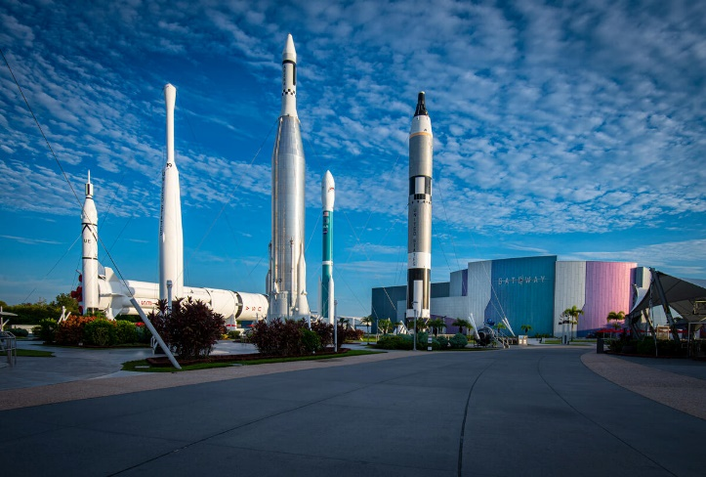
The KSC Master Plan states that “existing public outreach areas are retained and designated in the Future Land Plan promoting educational, research or informational connections between the community and KSC” (KSC 2022c). The purpose of the Proposed Action is to modernize the Administrative Building Complex used by VC support employees for offices, restrooms, break areas, and utility and storage areas.
KSC VC Rocket Garden
Due to the growth of the park and space needed for additional administrative staff a need was identified for a new admin building. The site for the new admin building was selected due to its proximity to M6-0409 where other admin employees are housed. The purpose of the new NBT experience would be to attract additional visitors and immerse them in a uniquely themed interactive environment of NASA’s historic past and future. The NBT would transform the KSC VC to a “must see” attraction for guests who might interpret the complex as a museum instead of the space experience the VC is striving to provide. The NBT would provide an additional experience to the complex to educate visitors about the NASA story while creating an environment where they can experience/feel space.
The Proposed Action is needed to provide visitors with continued access to NASA’s history through educational programs, attractions, and other similar experiences consistent with the KSC Master Plan and the existing concession agreement between Delaware North and KSC.
Figure 1-3 provides a map of the KSC VC. Delaware North submitted an Environmental Checklist to the KSC Environmental Management Branch, and a Record of Environmental Consideration (REC) for the Proposed Action was issued that required preparation of an EA. Appendix A provides the REC.
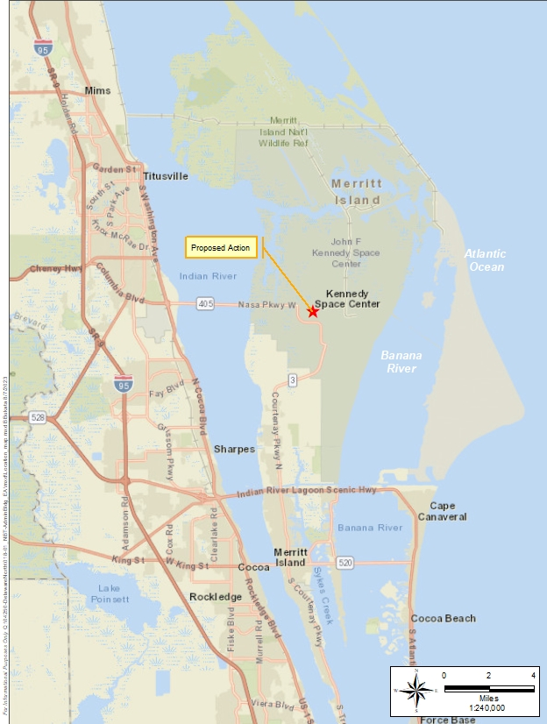
Figure 1-1 Regional Location Map

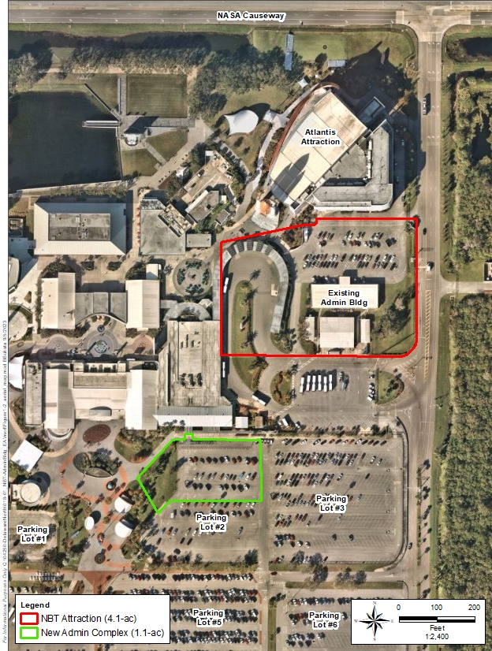
Figure 1-2 Aerial Location Map
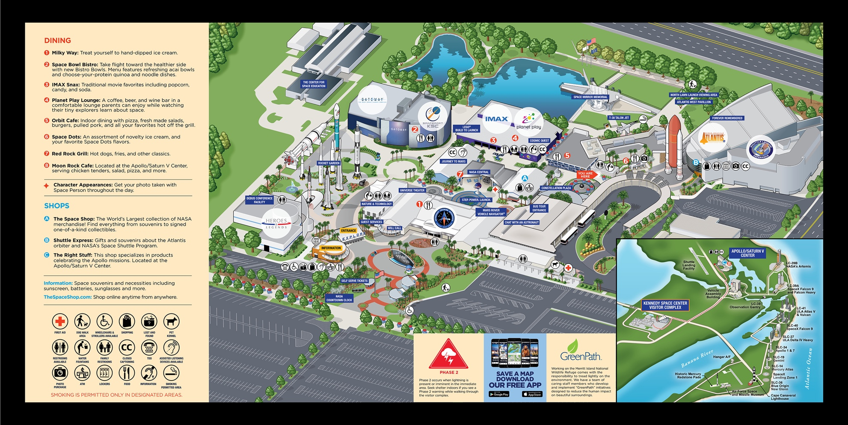
Figure 1-3 KSC Visitor Complex General Site Layout Map

Decision to be Made
The decision to be made is selecting an alternative for NASA regarding the Proposed Action. The decision options include the following:
- Maintain status quo (the No Action Alternative).
- Prepare an Environmental Impact Statement if the Proposed Action/Preferred Alternative would likely result in significant environmental effects.
- Select a preferred alternative and prepare a Finding of No Significant Impact.

Lead and Cooperating Agencies
This EA was prepared by Delaware North, the Proposed Action proponent. Delaware North manages the KSC VC in accordance with an existing concession agreement with NASA. NASA is the lead federal agency for the Proposed Action.
Due to the unique specificity of the Proposed Action and limited expected effects to potentially affected resource categories, Cooperating Agencies’ participation is not warranted for this EA.

DESCRIPTION OF PROPOSED ACTION AND ALTERNATIVES

Proposed Action
The Proposed Action is to relocate and modernize the existing Administrative Building Complex by constructing a new Administrative Building Complex with modernized employee offices, restrooms, break areas, and utility and storage areas on the existing Parking Lot 2 footprint. Following construction of the new complex, the existing Administrative Building Complex would be demolished, the existing retail warehouse would be demolished, the two trailers south of the existing Administrative Building Complex would be demolished or removed, and a new NBT experience would be constructed in its location to provide visitors with an enhanced space-exploration experience.
The Proposed Action would occur over a 5-year span. Construction on the new Administrative Building Complex is expected to begin in early 2024 and be complete within 12 months. Following construction of the new Administrative Building Complex, demolition of the previous complex and retail warehouse as well as removal of the two trailers would occur before construction of the new NBT experience. Demolition would begin in early 2026, and construction of the new NBT experience would be completed within 24 months from the onset of construction.
The new Administrative Building Complex is proposed on an approximately 1.1-acre (0.4-hectare) portion of Parking Lot 2 and would be approximately 50,000 gross square feet (gsf) (4,645.2 square meters [m²]) in size and one story in height (Figure 2-1). The new NBT experience is expected to occupy approximately 4.1 acres (1.7 hectares) of a previously developed impervious area with a height no greater than nine stories. The former Administrative Building Complex is one story and 28,000 gsf (2,601.3 m²) in size.
Major elements of the Proposed Action would include the following:
- Construction staging areas (i.e., laydown areas for the temporary storage of equipment and supplies) have not been identified in the preliminary design documents; however, staging areas would be on previously disturbed concrete, gravel, or grassy areas within the VC boundaries.
- Clean, unstained, unpainted concrete from demolition activities would be transported to the Diverted Aggregate Reclamation and Collection Yard. All other concrete would be sampled, and based on the results, transported to the Diverted Aggregate Reclamation and Collection Yard for reuse or the local construction and demolition debris landfill that is appropriate for receiving these materials. No burning of vegetation piles would occur, and all refuse would be disposed of in accordance with KSC regulations.
- The Proposed Action would maintain the KSC-required 100-foot (30.5-meter) fire buffer around the VC perimeter.

Figure 2-1 Conceptual Plan View Map of the Proposed Administrative Building Complex

- Construction workers would arrive at the KSC VC via buses, work trucks, or personal vehicles. Parking for these workers would be provided in the construction laydown area.
- Construction activities would occur during regular business hours. However, certain construction activities, such as concrete placement, may extend beyond these hours to accomplish activities that must be performed without interruption until completed. Most work is expected to occur during daylight, and no artificial lighting is expected to be needed.
- Typical construction equipment would include milling machines, excavators, bulldozers, graders, asphalt pavers, material transfer vehicles, compactors/rollers, water trucks, dump trucks, forklifts, scrapers, trenchers, line-up trucks, and pickup trucks.
- The Proposed Action would include installing appropriate power utilities, water/‌sewage utilities, and communication/fiber optic cables.
- The Proposed Action would incorporate site-specific health and safety requirements for construction workers per Occupational Safety and Health Administration regulations.
- Construction activities would be conducted in accordance with federal and state permits and applicable environmental regulations.
- The Proposed Action would incorporate Leadership in Energy and Environmental Design, commonly referred to as LEED, and sustainable development concepts to achieve optimum resource efficiency, sustainability, and energy conservation.
- The Proposed Action would comply with the U.S. Fish and Wildlife Service Biological Opinion for artificial lighting to mitigate impacts on nesting and hatchling sea turtles. Specifically, all facilities at KSC will operate amber light-emitting diode or exterior lights off between 9:00 PM and dawn May 1 through October 31, except where essential to support launch-related activities at active launch complexes.

Screening Factors
NEPA’s implementing regulations provide guidance on the consideration of alternatives to a Proposed Action and require rigorous exploration and objective evaluation of reasonable alternatives. Only those alternatives determined to be reasonable and to meet the purpose and need require detailed analysis. Potential alternatives that meet the purpose and need of the Proposed Action were evaluated against the following screening factors:
- Operational Growth. Any proposed alternative must support the potential future growth of the VC consistent with the KSC Master Plan.
- Location. Any proposed alternative must occur within the Space Commerce District’s
70-acre (28.3-hectare) VC to maintain consistency with the KSC Master Plan and concession agreement between Delaware North and KSC.
- Minimize or Avoid Unnecessary Adverse Environmental and Cultural Effects. Any alternative that would meet the Proposed Action’s purpose and need but would result in adverse environmental or cultural effects that could otherwise be avoided or minimized was not carried forward for detailed analysis. This criterion is consistent with NASA’s environmental stewardship commitments and reduces unnecessary mitigation and monitoring expenses.

Alternatives Carried Forward for Analysis
Using the screening factors listed in Section 2.2, reasonable alternatives were considered that met the purpose and need for the Proposed Action. As a result of that effort, the Preferred Alternative and No Action Alternative were carried forward for analysis.

No Action Alternative
Under the No Action Alternative, the existing Administrative Building Complex would not be relocated and modernized and a new NBT experience would not be constructed. Delaware North would not be able to achieve its goals and objectives of maintaining or increasing visitor attendance consistent with the existing concession agreement between Delaware North and KSC. Furthermore, connections between the community and KSC would be impeded since elements of the VC would not be refreshed to provide visitors with an ever-evolving, exceptional experience consistent with developments in space exploration.
The No Action Alternative would not meet the purpose and need for the Proposed Action; however, as required by NEPA, the No Action Alternative is carried forward for analysis and will be used to analyze the consequences of not undertaking the Proposed Action. The No Action Alternative establishes a comparative baseline for analysis.

Proposed Action (Preferred Alternative) – Replace Existing Administrative Building Complex and Construct the NBT Experience
After the screening factors were applied, only one reasonable action alternative existed; therefore, the Preferred Alternative, as described in Section 2.1, will be known as the Proposed Action; Figures 1-2 and 2-1 depict the project locations.
The Proposed Action would require compliance with the following permits:
- An Environmental Resource Permit (ERP) through St. Johns River Water Management District (SJRWMD) to construct a new stormwater management system. Although the VC has an existing stormwater management system in place, any necessary stormwater permit modifications will be obtained from SJRWMD, as required.
- A National Pollutant Discharge Elimination System (NPDES) Permit through the Florida Department of Environmental Protection (FDEP) for stormwater discharges associated with construction activities greater than 5 acres (2.0 hectares).
- FDEP water and wastewater permit modifications, if necessary.
Project construction under the Proposed Action is expected to begin in spring/summer 2024 and be completed within 5 years after the onset of demolition activities.

Alternatives Considered But Not Carried Forward to Detailed Analysis
NEPA (40 CFR 1502.14) requires that a reasonable range of alternatives be analyzed that are technically and economically feasible and meet the purpose and need of the Proposed Action. The following alternatives were considered but not carried forward for detailed analysis in this EA because they were not considered feasible, did not meet the purpose and need of the Proposed Action, and/or did not satisfy the screening factors presented in Section 2.2:
- Alternatives that would completely relocate the Administrative Building Complex or NBT experience outside the VC boundary were considered but eliminated from further consideration due to the existing infrastructure in place and the concession agreement between Delaware North and KSC.
- Alternative site locations for the new Administrative Building Complex or NBT experience within the VC boundary were considered but eliminated from further consideration due to the potential for greater adverse effects to wetland habitats, listed species, and/or floodplains.

Best Management Practices Included in the Proposed Action
This section presents an overview of the best management practices (BMPs) that are incorporated into the Proposed Action. BMPs are existing policies, practices, and measures included to reduce the environmental effects of designated activities, functions, or processes.
Although BMPs lessen potential effects by avoiding, minimizing, or reducing/eliminating effects, BMPs are distinguished from formal mitigation measures because BMPs are (1) existing requirements for the Proposed Action; (2) ongoing, regularly occurring practices; or (3) not unique to this Proposed Action. In other words, the BMPs identified in this EA are inherently part of the Proposed Action and are not potential mitigation measures proposed as a function of the NEPA environmental review process for the Proposed Action. Table 2-1 lists the BMPs.

Table 2-1 Best Management Practices
BMP | Description | Effects Reduced/Avoided
Stormwater Pollution Prevention Plan | Identifies how the contractor will implement procedures and practices to ensure compliance with the Installation’s stormwater pollution prevention plan (SWPPP) permit during construction activities.  This Plan also includes an Erosion and Sediment Control Plan to eliminate and/or minimize non-point-source pollution in surface waters, as well as a Stormwater Management Plan to reduce discharge of pollutants to storm drainage systems. | Reduces stormwater pollution.
Hazardous Materials Management Plan | Identifies how the contractor will safely transport, store, and dispose of hazardous materials. In addition, the plan will describe how spills will be controlled, personnel will be trained, and equipment maintained. | Reduces effects from hazardous materials.
Hazardous Waste Management Plan | Identifies how the contractor will minimize the generation of hazardous waste; control any spills; train personnel; and transport, store, use, handle, and dispose of hazardous waste. | Reduces generation of hazardous waste.
Spill Prevention Control and Countermeasures Plan | Identifies how the contractor will protect water bodies; minimize risks of spills, leaks, and releases; respond to spills, leaks, or releases; and minimize risk of human exposure to contaminated media. | Reduces effects from potentially hazardous materials.
Noise Abatement | Requires the contractor to ensure that all equipment has the manufacturer’s recommended noise-abatement measures intact, inspect construction equipment, turn off idling equipment when not in use, and perform work only during normal business hours. | Reduces effects from noise exposure.
Air Quality | Requires the contractor to inspect and maintain equipment, turn off idling vehicles and equipment to reduce emissions, and use new equipment when practicable that meets the most stringent applicable federal standards. | Reduces adverse effects to air quality.
Health and Safety Plan | 29 CFR Part 1910, Occupational Safety and Health Standards, and 29 CFR Part 1926, Safety and Health Regulations for Construction, require employees and their supervisors be trained in the specific hazards and control measures associated with their assigned tasks. The contractor will be required to prepare and implement a site-specific health and safety plan to document compliance with Occupational Safety and Health Administration regulations to include but not limited to management commitment and employee involvement, site characterization and job hazard analysis, hazard prevention and control, safety and health training, personal protective equipment, medical surveillance, exposure monitoring, emergency response, and recordkeeping and program evaluation. In addition to site-specific information, the job hazard analysis will include items related to construction-related noise, asbestos-containing materials, lead-based paint, polychlorinated biphenyls, and mercury-containing light bulbs. | Reduces potential risks associated with health and safety.

Affected Environment and Environmental Consequences
This chapter describes the environmental resources and baseline conditions that could be affected from implementing the Proposed Action and analyzes the potential direct and indirect effects.
Changes to the natural and human environment that could result from the Proposed Action are evaluated relative to the existing environmental conditions. The following four levels of effects may be identified:
- None – No measurable consequences.
- Negligible – The effect is barely perceptible or measurable, remains confined to a single location, and would not result in a sustained recovery time for the resource affected.
- Minor – The effect is readily perceptible and measurable; however, the effect would be temporary, and the resource should recover in a relatively short period.
- Moderate – The effect is perceptible and measurable, and may not remain localized, affecting areas adjacent to the Proposed Action area; adverse effects to a resource may require several years to recover.
- Major – An effect is predicted that meets the intensity/context significance criteria for the specified resource.
All potentially relevant environmental resource categories were initially considered for analysis in this EA. Discussion and analysis of the affected environment (i.e., existing conditions) focus only on resource areas potentially subject to effects. In addition, the level of detail describing each resource below is commensurate with the expected level of potential environmental effect. Section 3.1 presents, describes, and justifies resource categories that were assessed but not carried forward for detailed analysis due to negligible or non-existing adverse effects expected as a result of the Proposed Action.

Resource Categories Not Carried Forward for Detailed Analysis
The potential effects to the following resource areas are considered to be negligible or non-existent and were eliminated from detailed analysis in this EA – air quality, land use, biological resources, threatened and endangered species, geology and soils, noise, water resources, and environmental justice (Table 3-1). The following presents, describes, and justifies this determination for these resource categories.
Table 3-1 Summary of Potential Environmental Effects
Resource Category | Activity | Proposed Action | No Action
Transportation | Construction | Minor Adverse | None
 | Operation | Negligible | None
Utilities | Construction | Negligible | None
 | Operation | Negligible to Minor | None
Air Quality | Construction | Negligible | None
 | Operation | Negligible | None
Land Use | Construction | None | None
 | Operation | None | None
Biological Resources | Construction | None | None
 | Operation | None | None
Threatened and Endangered Species | Construction | None | None
 | Operation | Negligible | None
Cultural Resources | Construction | None | None
 | Operation | None | None
Geology and Soils | Construction | Negligible | None
 | Operation | None | None
Noise | Construction | Negligible | None
 | Operation | Negligible | None
Water Resources | Construction | Negligible | None
 | Operation | None | None
Environmental Justice | Construction | None | None
 | Operation | None | None
Socioeconomics | Construction | Minor Beneficial | None
 | Operation | Minor Beneficial | None

Air Quality: Under the Proposed Action, the Administrative Building Complex would be relocated to the existing Parking Lot 2 footprint, the existing Administrative Building Complex and retail warehouse would be demolished, the two trailers south of the existing Administrative Building Complex would be demolished or removed, and a new NBT experience would be constructed at the former Administrative Building Complex site. The new Administrative Building Complex would be on an approximately 1.1-acre (0.4-hectare) portion of Lot 2, up to 50,000 gsf (4,645.2 m²) in size, and one story in height. The new NBT experience is expected to occupy approximately 4.1 acres (1.7 hectares) of impervious area with a height no greater than nine. The existing Administrative Building Complex is one story and 28,000 gsf (2,601.3 m²) in size. In addition to the construction and demolition activities, temporary emissions from heavy-duty diesel-powered construction equipment, vehicular traffic, and fugitive dust emissions generated during construction are expected to occur. Following construction, operational-related emissions would occur from vehicular traffic and normal building operations (e.g., power generation, water heaters).
Construction is expected to occur over 5 years. Construction of the new Administrative Building Complex is expected to begin in early 2024 and be completed within 12 months. Following construction of the new Administrative Building Complex, demolition of the previous Administrative Building Complex would begin and construction of the new NBT experience in its location would occur. Demolition would begin in early 2026 and construction of the new NBT experience would be completed within 24 months from the onset of construction.
A negligible, localized, increase in annual emissions would occur at KSC from the implementation of the Proposed Action; additionally, implementation of the BMPs identified in Table 2-1 would further minimize air quality effects. These small increases in criteria pollutant emissions would have a negligible effect on Brevard County’s air quality, which is designated as “in attainment” with the National Ambient Air Quality Standards (NAAQS). Therefore, negligible adverse effects to air quality would occur from implementation of the Proposed Action.
Land Use: The KSC VC is in an area currently classified as Public Outreach land use, which includes facilities and associated land areas that promote an educational, research, or informational connection between the community and KSC. The Proposed Action would be consistent with the existing and future land use and visual character of the area; therefore, no adverse effect to land use would occur from implementation of the Proposed Action.
Biological Resources: The Proposed Action area comprises buildings and impervious parking lots and does not contain any vegetation communities or natural/vegetated habitat. As a result, the Proposed Action areas do not support wildlife species except for a few common species such as common lepidopteran or other insect species and potentially brown anoles (Anolis sagrei) that may forage among sparse ornamental plants that occur next to the existing administration complex building. Therefore, construction and operation of the Proposed Action are expected to have no adverse effects to biological resources.
Threatened and Endangered Species: The Proposed Action area comprises buildings and impervious parking lots and does not contain any habitat that could be used for refugia, foraging, or nesting by threatened and endangered species. As a result, construction and operation of the Proposed Action are expected to have negligible adverse effects to threatened and endangered species.
Geology and Soils: The Proposed Action would require the demolition and removal of the existing Administration Building Complex and parking lot including portions of Parking Lot 2. Areas would be regraded and excavation would occur for facility foundations, which may require the upper soil strata layers be removed. This limited excavation and subsequent construction of new facilities as a result of the Proposed Action would result in negligible adverse effects to geologic strata or soils of the local area or region. Furthermore, the BMPs listed in Table 2-1 would control runoff and prevent erosion during construction activities. No operational activities would require disturbing soils or geology of the Proposed Action site since the sites would be paved or contain buildings. As a result, operation of the Proposed Action would be expected to produce no adverse effects on the geologic strata or soils of the local area or region.
Noise: Ambient noise levels are expected to increase during construction activities and daily operations as a result of the Proposed Action site construction. Noise generated by construction vehicles is expected to be below all noise thresholds and would occur for a limited period. In addition, noise levels would increase marginally in the vicinity of Space Commerce Way and NASA Causeway temporarily due to increased construction traffic. However, this construction-related noise increase would be negligible compared to highway and regional noise levels. Furthermore, the BMPs listed in Table 2-1 would be used to reduce the effects from noise exposure. Operation of the Proposed Action is expected to have negligible adverse effect on noise levels locally along and adjacent to Space Commerce Way or NASA Causeway and negligible adverse effect on the noise levels regionally.
Water Resources: Perfluoroalkyl and polyfluoroalkyl substances (PFAS) contaminated surface and groundwater has been documented approximately 700 feet southwest of the proposed administration building (at the bus wash station) and approximately 900 feet northeast (site on the north side of NASA Causeway) of the proposed NBT. Any dewatering in association with site preparation before construction of the Proposed Action has the potential to cause migration of these contaminants. If dewatering is required, the contractor will prepare a dewatering plan and submit to the KSC Remediation Program for review and approval. Construction would not affect existing or off-site surface waters, wetlands, or floodplains since the Proposed Action area consists of buildings and impervious parking lots. Stormwater generated from the Proposed Action sites would be treated by the existing stormwater management system in accordance with SJRWMD regulations. As a result, construction and operation of the Proposed Action are expected to have negligible adverse effects to water resources.
Environmental Justice: The U.S. Environmental Protection Agency’s (USEPA’s) Environmental Justice Screening and Mapping Tool was used to determine if the area within 5 miles (8.0 km) of the Proposed Action had any Environmental Justice Indexes that were in the 50th or higher percentile when compared to the State of Florida or United States. The Environmental Justice Index combines demographic factors with a single environmental factor. USEPA reports an Environmental Justice Index for 13 variables, including particulate matter 2.5 micrometers or less in diameter (PM_{2.5}), ozone (O₃), diesel particulate matter, air toxics cancer risk, air toxics respiratory hazard index, toxic releases to air, traffic proximity, lead paint, Superfund proximity, Risk Management Program facility proximity, hazardous waste proximity, underground storage tanks, and wastewater discharge (USEPA 2023). Within 5 miles (8.0 km) of the Proposed Action location, no Environmental Justice Indexes exist that exceed the 50th percentile compared to the rest of the State of Florida or United States (USEPA 2023). Construction activities and VC operations would not alter the physical or social structure of the nearby community and no adverse effects would occur. Furthermore, no disproportionate high or adverse effects to minority or low-income populations or disproportionate environmental, health, and safety risks to children would occur from implementation of the Proposed Action.

Resource Categories Carried Forward for Detailed Analysis
Resource categories for which the Proposed Action is expected to cause potential effects include transportation, utilities, cultural resources, and socioeconomics. The sections below present the analyses of these resource categories.

Transportation
The existing road and bridge network serves all facilities and operations on KSC and CCSFS. KSC has 1.5 million square yards (1.3 km²) of parking areas, 2.8 million square yards (2.3 km²) of roads, six major automotive bridges, and one railroad bridge that serve KSC and CCSFS. KSC is served by over 564 miles (907.7 km) of roadways that include 184 miles (296.1 km) of paved roads and 380 miles (611.6 km) of unpaved roads, trails, and access roads (NASA 2022d).
The KSC VC is on Space Commerce Way, off NASA Parkway West, just before the KSC entrance. Of the four access roads onto KSC, NASA Parkway West serves as the primary access road for cargo, tourists, and personnel entering and leaving. This four-lane road originates in Titusville as SR 405 and crosses the Indian River Lagoon (IRL) onto KSC. The second point of entry onto KSC is from the south via Kennedy Parkway South, which originates on north Merritt Island as SR 3 (North Courtenay Parkway). This road is the major north-south artery for KSC. The third entry point is accessible from Titusville along Beach Road, which intersects Kennedy Parkway North. The fourth entry point is south of Oak Hill at the intersection of US Highway 1 and Kennedy Parkway North in Volusia County (Figure 3-1). Additionally, the KSC VC can be accessed from CCSFS via NASA Parkway East and Samuel C. Phillips Parkway.
Table 3-2 lists the average annual daily traffic (AADT) volumes, which reflect the total volume of traffic for a year divided by the total number of days per year.
Table 3-2 Daily Traffic Counts by Road Segment
Road Segment | Average Annual Daily Traffic
 | 2018 | 2019 | 2020 | 2021 | 2022
Space Commerce Way between NASA Parkway West and Kennedy Parkway | 3,600 | 3,600 | 2,800 | 2,800 | 4,600
NASA Parkway W. between South Washington Avenue and Space Commerce Way | 12,600 | 11,800 | 11,500 | 11,500 | 9,200
N. Courtenay Parkway between Space Commerce Way and Judson Road | — | — | 14,400 | — | 14,100
N. Courtenay Parkway between Judson Road and Hall Road | 15,000 | 14,800 | 14,400 | 14,400 | 14,100
Note: — = No data available.
Source: Florida Department of Transportation (FDOT) 2023a.

No Action Alternative
Under the No Action Alternative, the Proposed Action would not occur and no change to traffic patterns or additional trips would occur. Therefore, no adverse effects to Transportation would occur with implementation of the No Action Alternative.

Proposed Action
Construction: During the construction period, workers would arrive at the KSC VC via buses, work trucks, or personal vehicles and park at the construction laydown area. The construction laydown area would be on previously disturbed concrete, gravel, or grassy areas within the VC boundaries. The increase in vehicles would be temporary and occur during normal working hours. Therefore, during the construction of the Proposed Action, minor adverse effects on transportation would occur from the temporary increase in vehicles.

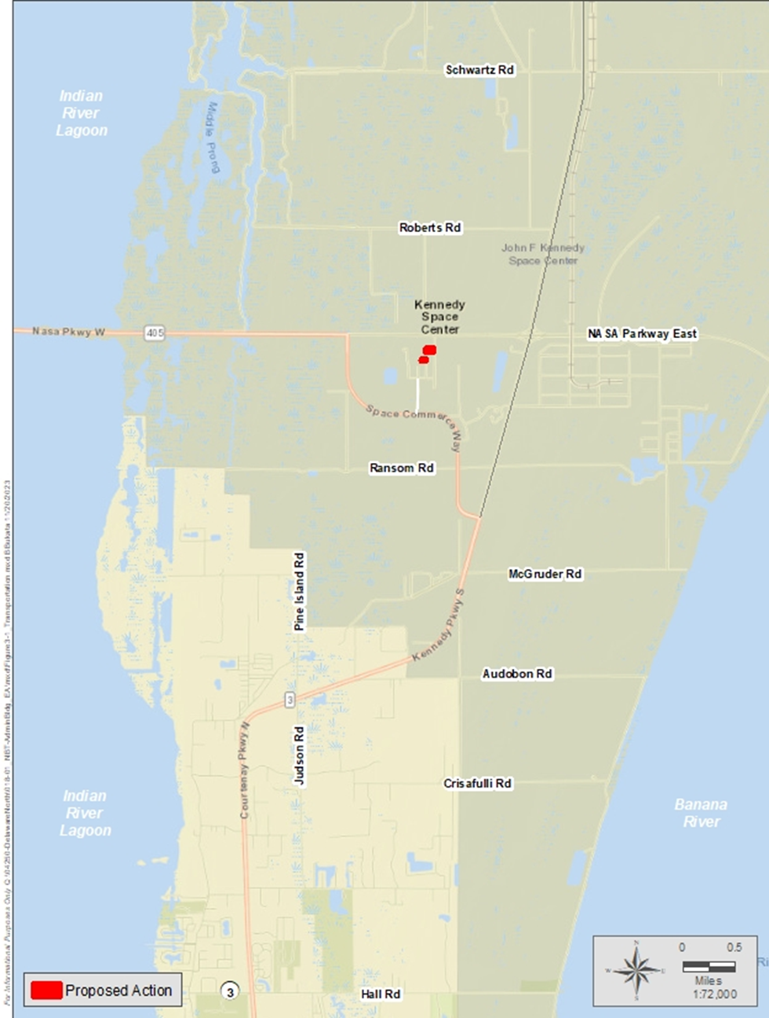
Figure 3-1 Transportation Map
Operation: The Proposed Action is not expected to increase the total number of permanent staff; however, the new NBT experience is expected to increase the total number of visitors by 10 percent annually. Therefore, daily traffic count numbers associated with the implementation of the Proposed Action for Space Commerce Way and NASA Parkway West are expected to increase slightly; however, FDOT has funded a $22.9-million project to widen 2.7 miles (4.3 km) of Space Commerce Way between NASA Parkway West to Kennedy Parkway from two lanes to four lanes (FDOT 2023b).
One purpose of the project is to provide improved access for daily visitors to the KSC VC; the project began in summer 2023 and is expected to be completed by spring 2025 (FDOT 2023c), which is before the opening of the new NBT experience. Since the widening of Space Commerce Way would reduce the overall effect from the increase in visitors, negligible adverse effects on transportation are expected during the operational phase of the Proposed Action.

Utilities

No Action Alternative
Under the No Action Alternative, the Proposed Action would not occur and no changes in utility demand would occur. Therefore, no adverse effects to utilities would occur with implementation of the No Action Alternative.

Proposed Action
Wastewater: Sanitary sewer service at KSC is provided by a wastewater collection and transmission system that is separated into two primary areas – one in the Industrial Area and one in the Vehicle Assembly Building area. The combined flows are pumped through a force main across the Banana River to the CCSFS Regional Wastewater Treatment Facility (RWWTF). The VC has on-site wastewater system components including gravity sewers, manholes, lift stations, and force mains serving the VC facilities. These wastewater system elements are part of KSC’s greater Industrial Area system. The KSC wastewater system and the downstream CCSFS RWWTF are approaching capacity limits due to current flows and ongoing development at KSC.
For the Proposed Action, the wastewater collection would be modified to collect domestic wastewater flows from the new facilities. This would be accomplished with gravity laterals or via new wastewater lift stations and force mains depending on topography and proximity to existing wastewater collection system infrastructure.
The wastewater flows expected to be produced by the Proposed Action would be a relatively negligible increase in the existing flows at the VC. The only added flows would be the result of increased visitor attendance attracted by the NBT experience and additional staff operating the attraction. The proposed new Administrative Building Complex is a relocation of an existing function, so the relocation construction does not add flow to the wastewater system. Furthermore, the Proposed Action would incorporate LEED, which would consider and include measures to conserve water. In March 2022, the Space Florida Executive Board approved $10 million for design and construction of new pumping stations and a sanitary sewer force main to the Brevard County Sykes Creek WWTF to convey all wastewater flow from the Space Commerce District south and north areas of KSC, which are areas east of Kennedy Parkway and south of Sharkey Road occupied by commercial aerospace companies including Blue Origin, SpaceX, and others. This will divert a significant wastewater load away from the CCSFS RWWTF and KSC’s regional lift station LS-1AA. This diversion ensures that the CCSFS RWWTF does not exceed its permitted capacity of 0.80 MGD annual average daily flow (AADF) until 10 to 15 years in the future.
The current KSC system should have available capacity for the minor increase in wastewater flows expected from the Proposed Action. As such, the construction and operation of the Proposed Action are considered to cause negligible to minor adverse effects to the wastewater system.
Power: The electric power distribution system at KSC is provided by Florida Power & Light Company (FPL), which transmits 115 kilovolts (kV) to KSC through two major substations – the C-5 substation that serves the Launch Complex 39 (LC-39) area providing 13.8 kV and the Orsino substation that serves the Industrial Area providing 13.2 kV. From 2014 through 2019, electricity usage on KSC ranged between 102,832 (2019) and 187,793 (2014) megawatt-hours. Electricity consistently provides 91 percent of KSC’s total energy (NASA 2020a). The high-voltage power is distributed from the substations by over 270 miles (434.5 km) of overhead and underground power lines to transformers and substations at various facilities. In late 2016, FPL installed a new “Mars” substation along Space Commerce Way to serve commercial aerospace customers along Space Commerce Way, Space Florida facilities in Exploration Park I, and the KSC VC. In addition, FPL has constructed a solar farm south of Jerome Road on Kennedy Parkway South and recently completed construction of an approximately 500-acre (202.3-hectare) solar farm north of the VC.
As part of the new South Entrance completed in 2021 (Galaxy Way), FPL extended a feeder from the Mars substation to a service connection point on Galaxy Way southeast of the new VC Parking Plaza. This service provides power to the Parking Plaza, Lots 7 and 8, and the wastewater lift station in the area. The FPL service is a 150-kilovolt-amp (kVA) transformer with three-phase, 480-volt service. This transformer was designed to be loop fed to allow the service to continue using the same circuit and provide additional power to the area.
For this Proposed Action, Delaware North is planning and designing an extension of FPL’s medium-voltage (13.2 kV) distribution system to the VC. The new service distribution system would extend to the VC north from Galaxy Way near the Parking Plaza and Lot 7, would serve future developments along the main access drive that runs along the east side of Parking Lots 1, 6, and 7 north of the VC entrance, and is expected to be constructed within the next 5 years.
The Proposed Action facilities would be LEED Silver facilities, which would reduce energy consumption of the buildings. As a result, the construction and operation of the Proposed Action are expected to have negligible to minor adverse effects on power.
Communications: The KSC communications system provides a variety of services at KSC including (1) conventional telephone service, (2) transmission of large volumes of test data to central collection or reduction stations, (3) transmission of timing information from operation centers to data-gathering instrumentation at widely scattered locations, (4) transmission of weather and range safety data, and (5) communication with satellites and other hardware in space. The major segments are the three distribution and switching stations in the Industrial Area (First Switch) and the LC-39 area (Second and Third Switches).
The VC area is served with communications infrastructure from KSC and independent vendors. These communications currently flow through the communications infrastructure housed within the Industrial Area at KSC. For the Proposed Action, necessary communication lines would be installed and connected to the existing system using the existing NASA infrastructure. The existing communications system can provide the necessary increased capacity for these new facilities. As such, the construction and operation of the Proposed Action are expected to have negligible to minor adverse effects to the communications system.
Potable Water: KSC’s potable water is supplied by the City of Cocoa, which obtains its water from artesian wells west of the St. Johns River in Orange County as well as the Taylor Creek Reservoir. Water enters KSC along SR 3 from a 24-inch (61.0-centimeter [cm]) water main and extends north along Kennedy Parkway to serve KSC. The average daily demand for water is 700,000 gallons per day (2.6 million liters per day). Various aboveground storage tanks and secondary pump systems supply water throughout KSC (NASA 2019).
For the Proposed Action, new water service pipelines for fire protection and potable water are expected to be extended from a 12-inch (30.5-cm) water main (currently under construction), running along the main access road adjacent to the east of the proposed NBT experience and Administrative Building Complex sites. Based on the occupancy of the proposed facilities, the potable water consumption is expected to be relatively low and a negligible increase over current water demands. Fire flow requirements are expected to be commensurate with other similar occupancies in the area. KSC water system modeling for this area indicates sufficient flow would be available to accommodate fire flows. As such, the existing water distribution system can provide the necessary increased capacity for the new facilities. Based on the size of the existing water main and expected demand associated with new facilities, the construction and operation of the Proposed Action are expected to have a negligible to minor adverse effect on the potable water infrastructure.

Cultural Resources
Cultural resources that are historic properties are one component of the human environment considered under NEPA. Sites, buildings, structures, objects, or districts, including Traditional Cultural Properties (TCPs) containing enough significance and integrity to be listed on the National Register of Historic Places (NRHP), are defined as historic properties that are protected under the National Historic Preservation Act (NHPA) of 1966 as amended. These cultural resources generally become eligible for consideration as a historic property after reaching 45 to 50 years of age. Section 106 of the NHPA requires that every federal agency “take into account” how each undertaking could affect historic properties. NASA complies with 36 CFR Part 800 (Protection of Historic Properties), the implementing regulations to Section 106 of the NHPA. In addition, KSC Cooperative Agreement 4185 (Programmatic Agreement for Management of Historic Properties at KSC) outlines how the Section 106 process will be implemented at KSC including consultation and a comment period for the Advisory Council on Historic Preservation, State Historic Preservation Officer (SHPO), and tribes. Other federal laws that NASA complies with, such as the Native American Graves and Repatriation Act (NAGPRA) and the Archaeological Resources Protection Act (ARPA), consider impacts to cultural resources that may or may not meet the NRHP criteria to be considered a historic property under the NHPA. KSC’s Integrated Cultural Resources Management Plan (ICRMP) outlines the various statutes and regulatory framework governing protection and documentation of our heritage (NASA 2018).
For this project, an Area of Potential Affect (APE) was established to identify cultural resources present and to evaluate potential effects to historic properties, those cultural resources that are significant enough for inclusion in the NRHP. The APE encompasses the construction footprints for the two project areas, as well as the viewshed of the proposed projects within the KSC VC built environment.
For archaeological resources, no known archaeological sites exist within the APE, and all work will take place within previously developed and disturbed areas. A 1990 survey titled Archaeological Survey to Establish Zones of Archaeological Potential (ZAPs) in the Vehicle Assembly Building and Industrial Areas of the Kennedy Space Center (Florida Master Site File [FMSF] Report No. 2471) identified this area as having a low potential for archaeological resources. Within KSC, areas that have low ZAPs and/or no known archaeological sites within or in the vicinity of the APE generally do not require an archaeological survey, and the presence of significant archaeological sites was determined to be unlikely within the archaeological APE.
Furthermore, a review of historic topographic maps indicated that the parking lot where the new Administration Building Complex is proposed was once a ponded wetland and subsequently disturbed with construction (Figures 3-2 and 3-3). Likewise, the new NBT experience area was previously disturbed by agricultural and construction activities (Figures 3-4 and 3-5). Although not directly subject to subsurface testing, multiple areas adjacent to the KSC VC have undergone subsurface survey with negative results; therefore, intact archaeological remains are likely not present in the APE.
In August 2023, LG2 Environmental Solutions, Inc. conducted a survey of buildings and structures 45 years or older within the APE. The four administration buildings slated for demolition do not meet the 45-year threshold for evaluation and have no exceptional importance that would warrant consideration for NRHP eligibility. The Guard House (M6-0362) was built in 2001; the Receiving Building (M6-0409H) was built in 1982; and two temporary trailers (TRM-0054 and TRM-0055) were installed in 2004.
The new administration building would be constructed adjacent to four structures built in the 1960s and 1970s. This includes the original KSC Visitor Center (M6-0409) built in 1967, a restaurant building (M6-0409C) built in 1972, a dog kennel (M6-0409F) built in 1976, and a first-aid station (M6-0411) built in 1963. A determination of eligibility for these structures concluded that none are eligible for the NRHP.
The new exhibit hall would be constructed within the viewshed of five buildings constructed in the 1960s and 1970s. This includes the four discussed above in addition to a cafeteria (M6-0409D) built in 1976. A determination of eligibility for this structure concluded that it is not eligible for the NRHP. Other buildings within the viewshed are the Shuttle Launch Experience Facility
(M6-0213) built in 2006 and the Souvenir Sales Building (M6-0409G) built in 1982. These buildings do not meet the 45-year threshold for evaluation and have no exceptional importance that would warrant NRHP eligibility.
The KSC VC was also evaluated as a potential historic district. It was concluded that a historic district does not exist due to extensive changes and additions within the KSC VC leading to a lack of historic continuity or an aesthetic or historic plan that links them together.

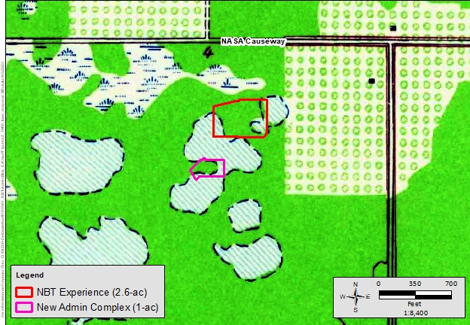
Structures
Ponds
Wetlands
Orange Groves
Ponds
Figure 3-2 c.1960 USGS Topographic Location Map, Orsino, Florida, Showing APEs in Ponded Wetlands
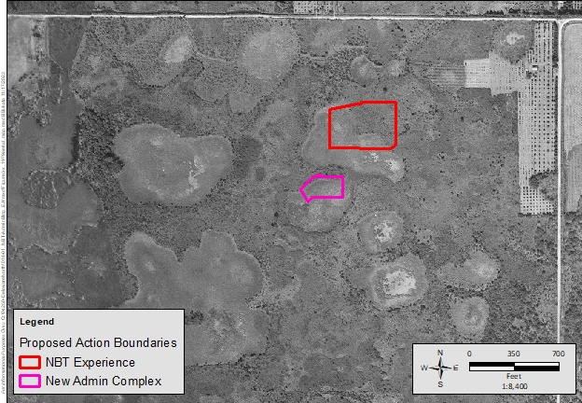
Figure 3-3 c.1943 Aerial Photograph, Flight 2C, Showing APEs in Ponded Wetlands
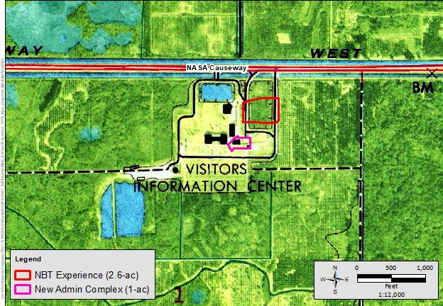
Road

Figure 3-4 c.1976 USGS Topographic Location Map, Orsino, Florida, Showing VC Experience in Previously Disturbed Area
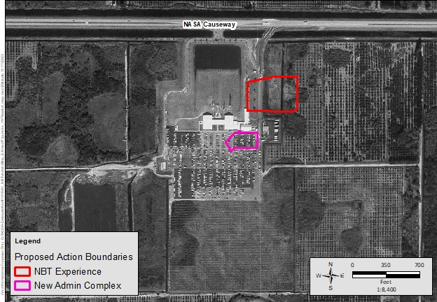
Figure 3-5 c.1969 Aerial Photograph, Flight 1KK, Showing VC Experience in Previously Disturbed Area
In accordance with applicable laws and regulations, NASA Cultural Resources Manager initiated consultation with appropriate agencies and interested parties on October 24, 2023. On November 21, 2023, the SHPO concurred with NASA’s determination that no historic properties are recorded within the APE. Appendix B of this EA includes the October 2023 structures survey letter report and agency correspondence letters.

No Action Alternative
Under the No-Action Alternative, the Proposed Action would not be implemented, and the area would remain undeveloped. As such, no effects to cultural resources would occur.

Proposed Action
NASA KSC has determined that the APE does not contain any historic properties or districts that are eligible for or listed in the National Register of Historic places. Therefore, no historic properties would be affected by the undertaking. The presence of unknown archaeological sites would be unlikely due to previous land modifying activities, but in the event that any unexpected discovery of archaeological material or human remains were to occur during construction activities for the project, KSC would follow the procedures outlined in the ICRMP and the KSC Cooperative Agreement 4185 through consultation with the appropriate parties. On November 21, 2023, the SHPO concurred with NASA’s determination that no historic properties will be affected by this undertaking, following the special conditions for unexpected discoveries, to be implemented by NASA which cover:
If prehistoric or historic artifacts, such as pottery or ceramics, projectile points, dugout canoes, metal implements, historic building materials, or any other physical remains that could be associated with Native American, early European, or American settlement are encountered at any time within the project site area, the permitted project shall cease all activities involving subsurface disturbance in the vicinity of the discovery. … Project activities shall not resume without verbal and/or written authorization. In the event that unmarked human remains are encountered during permitted activities, all work shall stop immediately ...

Construction: No significant cultural resources were identified within the APE; therefore, construction of the Proposed Action would generate no effects to cultural resources.
Operation: No significant cultural resources were identified within the APE; therefore, operation of the Alternative Action would result in no effects to cultural resources.

Socioeconomics
The FY 2021 economic output effect associated with NASA KSC expenditures was approximately $5.25 billion for Florida, yielding a total income contribution of $2.77 billion. Overall, the economic activity associated with KSC supported 27,004 Florida jobs in FY 2021, an 11.8-percent increase over FY 2019. Specific to Brevard County, 21,444 jobs were attributable to KSC, an increase of 8.5 percent (NASA 2022a).
During FY 2021, the KSC VC resulted in an economic output effect of approximately $148.3 million for the State of Florida, which supported approximately 1,390 jobs and $79.3 million in total income (value added) (NASA 2022a).
KSC is a cultural attraction, and the VC provides educational opportunities to guests from all over the world. Founded in 1960s to build on the support and goodwill of the public with the Mercury program, KSC VC has grown to encompass a launch-viewing area, virtual space exploration experiences, an IMAX theatre, eateries, retail, and objects of significance on display, like the rocket garden. With the increase in launches to space with commercial space entities comes an increase in visitors to the KSC VC. As the space industry continues to grow, expand, and evolve, the KSC VC would grow as well.

No Action Alternative
Under the No-Action Alternative, the Proposed Action would not be implemented. As a result, no adverse effects would occur to socioeconomics.

Proposed Action
Construction: The Proposed Action would support the local economy since the construction phase of this project is expected to generate temporary jobs for the local workforce with an expected positive effect on the local economy. Construction of the Proposed Action would not significantly affect the local housing market and would not negatively affect the local economy. KSC is a cultural attraction with visitors who may have sensitivities to the dust or noise from construction, which could affect their experience. The BMPs listed in Table 2-1 would be used to reduce effects from dust and noise. Therefore, during the construction of the Proposed Action, minor beneficial effects to socioeconomics would occur.
Operation: Operation of the Proposed Action is not expected to significantly increase the total number of employees immediately; however, as the number of visitors increase, a small number of additional support staff are expected to be employed. Although a slight increase in the local population from the Proposed Action may occur with a minor increase in the VC workforce, the population growth rate is expected to be nominal. Furthermore, the Proposed Action would not significantly affect the local housing market and would not negatively affect the local economy. Additional development within the KSC VC footprint would allow for more guests to experience the attractions and provide innovative technological advancements to the VC by constructing a new NBT experience. The location would provide a fluid transition from the current attraction footprint to the new, proposed NBT adjacent to the Space Shuttle Atlantis experience. Therefore, during the operational phase of the Proposed Action, minor beneficial effects would occur.
KSC VC Rocket Garden

CUMULATIVE EFFECTS

Definition of Cumulative Effects
The approach taken in the analysis of cumulative effects in this document follows the objectives of NEPA, CEQ regulations, and CEQ guidance. Cumulative effects are defined in 40 CFR Section 1508.1 as follows:
…effects on the environment that result from the incremental effects of the action when added to the effects of other past, present, and reasonably foreseeable actions regardless of what agency (Federal or non-Federal) or person undertakes such other actions. Cumulative effects can result from individually minor but collectively significant actions taking place over a period of time.
Cumulative effects are most likely to arise when a relationship or synergism exists between a Proposed Action and other actions expected to occur in a similar location or during a similar time period. Actions overlapping with or near the Proposed Action would be expected to have more potential for a relationship than those more geographically separated. Similarly, relatively concurrent actions would tend to offer a higher potential for cumulative effects. To identify cumulative effects, the analysis needs to address the following three fundamental questions:
- Does a relationship exist such that the effects to affected resource areas by the Proposed Action might interact with the effects to resources of past, present, or reasonably foreseeable actions?
- If so, what would the combined effect be?
- Do any potential unidentified significant effects exist when the Proposed Action is considered alone?

Scope of Cumulative Effects Analysis
The scope of the cumulative effects analysis involves the geographic extent of the effects and their timeframes in which the effects could be expected to occur. For this EA, the study area delimits the geographic extent of the cumulative effects analysis. In general, the study area includes the areas previously identified in Chapter 3 for the respective resource areas. The timeframe for cumulative effects centers on the timing of the Proposed Action. Although the construction timeline is not finalized, the Proposed Action is expected to take approximately 5 years, beginning in spring/summer 2024.
Another factor influencing the scope of cumulative effects analysis involves identifying other actions to consider. Beyond determining the geographic scope and timeframe for the actions interrelated to the Proposed Action, the analysis employs the measure of “reasonably foreseeable” to include or exclude other actions. For this analysis, reasonably foreseeable is defined in 40 CFR 1508.1 as, “sufficiently likely to occur such that a person of ordinary prudence would take it into account to reach a decision.”
Documents used to identify other actions include notices of intent for Environmental Impact Statements and EAs, management plans, land use plans, and other planning-related studies or publications.

Past, Present, and Reasonably Foreseeable Actions
In determining which projects to include in the cumulative effects analysis, a preliminary determination was made regarding the past, present, or reasonably foreseeable action. First, it was determined whether a relationship exists such that the affected resource areas of the Proposed Action (included in this EA) might interact with the affected resource area of a past, present, or reasonably foreseeable action. If no such potential relationship exists, the project was not carried forward into the cumulative effects analysis. To focus the analysis on meaningful actions relevant to informed decision-making, projects not carried forward into the cumulative effects analysis are not catalogued in this EA.

Widening of Space Commerce Way (2023–2025)
FDOT has funded a $22.9-million project to widen 2.7 miles (4.3 km) of Space Commerce Way between NASA Parkway West to Kennedy Parkway from two lanes to four lanes (FDOT 2023b) (refer to Figure 4-1). This widening project will support future growth and economic vitality by allowing the transportation of oversized space industry vehicles to launch sites, as well as regular public and commercial traffic between the mainland near Titusville and North Merritt Island (and other barrier islands in that vicinity). The project will also provide visitors with access to the KSC VC and support the manufacturing and research workforce of Exploration Park (FDOT 2023b).
During the widening effort, intermittent lane closures on Space Commerce Way will occur; however, signage will be erected to alert drivers of detours. No closure to side streets, residences, and business will occur (FDOT 2023c).
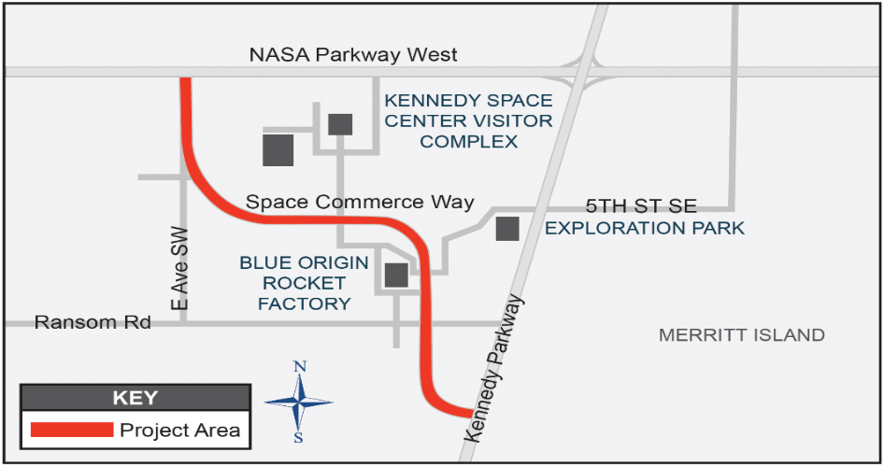
Figure 4-1 Space Commerce Way Widening Project Area
Source: FDOT 2023c.

KSC VC 15-Year Development Plan (2025 – 2040)
Delaware North is preparing a Programmatic EA (PEA) to assess the potential environmental effects associated with a 15-year development plan. The Draft PEA is expected to be released for public review in summer 2024; however, areas identified for development within the upcoming 15-year planning horizon are shown in Figure 4-2.
Specific to the timing of projects, in addition to this EA, NEPA documentation is being developed for the new warehouse. A new education center is also expected to be constructed in the next 5 years. A new launch-viewing area, parking areas, and regional stormwater treatment and natural areas are expected to occur in the next 6 to 10 years. The new attractions proposed for Lots 3 and 4 and a hotel or conference center would occur in the next 11 to 15 years. Although how these proposed future projects would increase personnel or visitor counts is not known, changes in both would be reasonably expected to occur. However, without a defined project, personnel changes cannot be predicted with any fidelity at this time. The PEA is expected to include an analysis of these projects and their potential effects.

Cumulative Effect Analysis
As discussed in Section 3.1, the Proposed Action was found to result in no or negligible direct/‌indirect adverse effects to air quality, land use, biological resources, threatened and endangered species, geology and soils, noise, water resources, and environmental justice. Since the direct and/or indirect effects to these resource areas are localized and temporary and the respective resources are expected to recover within a short period, another action would need to occur in the same localized area at the same time for cumulative effects to be possible. Therefore, these resource areas are not carried forward in the cumulative effects analysis.

Transportation
As discussed in Section 3.2.1, minor adverse effects would occur from construction of the Proposed Action and negligible adverse effects from operation of the Proposed Action. Overlapping the Proposed Action construction timeline is the widening of Space Commerce Way, which began in summer 2023 and is expected to be completed by spring 2025. During the widening effort, lane closures will occur intermittently, resulting in cumulative adverse effects. To minimize the effects from these closures, signage will be used to alert drivers of detours, and side streets, residence, and businesses will remain available. The widening project is expected to be completed before the opening of the new NBT experience and is expected to provide visitors with improved access to the KSC VC. Therefore, the overall cumulative effect when combined with other past, present, and reasonably foreseeable future actions on transportation during the construction phase of the Proposed Action is considered minor.

Utilities
As discussed in Section 3.2.2, negligible to minor adverse effects would occur from construction of the Proposed Action and negligible adverse effects from operation of the Proposed Action.
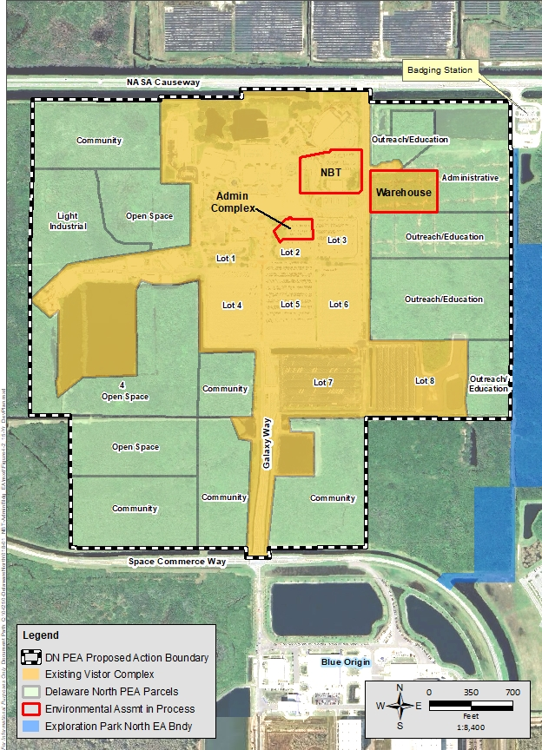
Figure 4-2 Proposed 15-Year KSC VC Development Plan

Wastewater System
The KSC wastewater system and the downstream CCSFS RWWTF are approaching capacity limits due to current flows and ongoing development at KSC. NASA completed a Wastewater Reliability Study and Master Plan (KSC-NE-15841) in July 2022 to address the capacity concerns with KSC’s wastewater system. The Study created a systemwide hydraulic model and evaluated needed wastewater system improvements over a 20-year horizon based on future wastewater flow projections. The Study included assessing the condition and capacity of master pumping stations LS-4A and LS-1AA and their force mains, evaluating emergency power needs, determining upgrades to correct existing system deficiencies, and identifying projects for increasing capacity to handle projected flows. The capacity concerns with KSC’s system and the CCSFS RWWTF are being addressed via several major planned steps, including the following.
- The KSC Wastewater Reliability Study and Master Plan identified system improvements that will be needed over time as flows at KSC increase, including upgrading LS-4A and LS-1AA, upsizing major force mains, and replacing an obstructed and underperforming force main crossing the Banana River to CCSFS. Upgrade timeframes for the CCSFS RWWTF are also outlined in the Study.
- In March 2022, the Space Florida Executive Board approved $10 million for the design and construction of new pumping stations and a sanitary sewer force main to the Sykes Creek WWTF to convey all wastewater flow from the Space Commerce District south and north areas of KSC, which are areas east of Kennedy Parkway and south of Sharkey Road occupied by commercial aerospace companies including Blue Origin, SpaceX, and others. This will divert a significant wastewater load away from the CCSFS RWWTF and KSC’s regional lift station LS-1AA. The Study shows that by diverting wastewater flows from Space Commerce Districts south and north to the Brevard County Sykes Creek WWTF, the CCSFS RWWTF does not exceed its permitted capacity of 0.80 MGD AADF until 10 to 15 years in the future.
- In November 2023, the U.S. Space Force, Space Launch Delta 45 (SLD-45), announced in a Memorandum to all Eastern Range Users, that to ensure adequate capacity at the CCSFS RWWTF into the future, and to improve processing efficiency, the SLD-45 is eliminating any new non-nutritive discharges (e.g., chiller blowdown, heating, ventilation, and air-conditioning [HVAC] condensate, launch deluge water, etc.) to the CCSFS RWWTF and existing non-nutritive wastewater discharges from existing facilities by June 1, 2027. This will create/recover capacity at the CCSFS RWWTF and in the KSC wastewater system.

Water System
The KSC water distribution system recently underwent a major, multi-year, multi-phase upgrading that ensures sufficient domestic water and fire flow to most areas of KSC. Certain parts of the system, including the former Shuttle Landing Facility and KSC VC, have more localized capacity limitations that are being addressed by ongoing projects. At the KSC VC, Delaware North is currently constructing a new water main extension to complete a water system “loop.” The KSC VC is currently supplied water from a NASA 12-inch-diameter water main along NASA Causeway. The new loop will connect the KSC VC water system supply main to an existing water main along Space Commerce Way that is supplied by NASA’s 36-inch diameter main along Kennedy Parkway. The looping will boost fire flow and pressure to support all foreseeable growth at the KSC VC including the proposed growth outlined in the separately prepared PEA.
As mentioned in Section 3.2.2.2, the Proposed Action does not add significant new flow to the KSC Wastewater System. The new buildings under the Proposed Action are expected to seek LEED certification, which would help to conserve water and reduce wastewater.

Power Supply
As mentioned in Section 3.2.2.2, Delaware North is planning and designing an extension of FPL’s medium-voltage (13.2 kV) distribution system to serve future developments along the KSC VC main access drive, which runs along the east side of Parking Lots 1, 6, and 7 to the north VC entrance, expected within the next 5 years. Therefore, adequate power supply will be available for all near-term developments including the NBT and new Administrative Building Complex as well as other planned developments such as electric vehicle bus charging locations, a warehouse, and a new Launch Stadium (to be evaluated further in the PEA).
The new buildings under the Proposed Action are expected to seek LEED certification, which would help to conserve water, reduce wastewater, and reduce energy consumption. As part of the Delaware North PEA (being prepared separately), utility demands and capacity of these KSC systems would be re-evaluated to ensure the existing capacity is adequate for the planned development or identify what system changes would be necessary. Therefore, the overall cumulative effect when combined with other past, present, and reasonably foreseeable future actions on utilities is considered negligible.

Cultural Resources
As discussed in Section 3.2.3, no effects would occur from construction of the Proposed Action or operation of the Proposed Action because no cultural resources that are historic properties are present within the APE. KSC will continue to comply with Section 106 of the NHPA, KSC Cooperative Agreement 4185, the ICRMP, an unexpected discovery plan, and all other relevant laws and regulations. Therefore, no overall cumulative effects when combined with other past, present, and reasonably foreseeable future actions would occur on cultural resources.

Socioeconomics
As discussed in Section 3.2.4, minor beneficial effects would occur from construction and operation of the Proposed Action.
Short-term beneficial effects from the Proposed Action and other similar efforts would occur from past, present, and reasonably foreseeable projects. However, the overall scope of the construction associated with the Proposed Action is relatively small and short in duration. Although an increase in construction spending resulting from a short-term demand for construction and secondary jobs is expected, the regional labor force would likely absorb the increased demand for direct construction and associated secondary jobs. Furthermore, construction spending as well as additional taxes would accrue to federal, state, and local governments as a result of the increased construction activities; however, these would be minor and temporary.
Long-term cumulative effects are associated with the Proposed Action and other similar efforts from present and reasonably foreseeable projects as a result of an increase of visitors. In 2021, nearly 960,000 guests visited the 70-acre (28.3-hectare) KSC VC (NASA 2022a). During FY 2021, VC visitation resulted in an economic output effect of approximately $148.3 million for the State of Florida, which supported approximately 1,390 jobs and $79.3 million total income (value added) (NASA 2022a).
As discussed in Section 3.2.4, minor adverse effects would occur from construction of the Proposed Action and minor beneficial effects from operation of the Proposed Action. Implementation of BMPs listed in Table 2-1 as part of the Proposed Action would minimize any short-term adverse effects associated with dust and noise. As part of the PEA, cultural socioeconomic effects would be evaluated to ensure that no long-term adverse cumulative effects occur.
The beneficial cumulative effects associated with the Proposed Action and other past, present, and future actions would not be significant as a development plan is underway to ensure the proper infrastructure exists to accommodate the increase in visitors. Therefore, the beneficial socioeconomic effect from other past, present, and reasonably foreseeable future actions when considered incrementally with the Proposed Action would not be significant.

PREPARERS, CONTRIBUTORS, AND CONTACTS
Table 5-1 lists the individuals who provided details, data, or analyses and who prepared this document. The table provides information concerning which section(s) each person was involved in writing or assembling.
Table 5-1 List of Individuals Who Prepared This Document
Preparers | Affiliation | Professional Title | Contribution
Bukata, B.J., MS, PWS, AA | Jones Edmunds | Senior Scientist/Vice-President | Project Manager, Biological Resources, Natural Resources, Transportation, Utilities, Document Compilation, Data, and Text
Koller, Rich, PE | Jones Edmunds | Managing Director | Utilities, QA/QC Document Review
Mike Clark, PE | Jones Edmunds | Senior Engineer | Utilities
Berry, Stephen | LG2 Environmental Solutions | Senior NEPA Analyst | DOPAA, Senior QA/QC Document Review
Everson, Chrystal | LG2 Environmental Solutions | Senior NEPA Lead | DOPAA, Cumulative Effects, QA/QC Document Review
Puckett, Wendy | LG2 Environmental Solutions | Cultural Resource Manager Team Lead | Cultural Resources, Socioeconomics
Schmid, Joe | Jones Edmunds | Department Manager, Technical Communications | Document Review
Vaseen, Nancy | Jones Edmunds | Technical Editor | Document Review
Parrish, Gina | Delaware North | Environmental Manager | Document Review
Mayo, Jennifer | Delaware North | Sr. Manager of Project Development | Document Review
Dankert, Don | NASA/KSC | KSC NEPA Program Manager | Document Review
Brooks, James | NASA/KSC | KSC NEPA Coordinator | Document Review
Collins, Jeff | NASA/KSC | KSC Environmental | Document Review
Zeringue, Katherine | NASA/KSC | Historic Properties Manager | Cultural Resources Review

LITERATURE CITED
ACI. 1992. Archaeological Survey to Establish Zones of Archaeological Potential (ZAPs) in the Shuttle Landing/KSC South Areas (Option 2) of the Kennedy Space Center.
ACI. 1990. Archaeological Survey to Establish Zones of Archaeological Potential (ZAPs) in the Vehicle Assembly Building and Industrial Areas of the Kennedy Space Center.
Delaware North. 2023a. Kennedy Space Center Visitor Complex Quick Facts. Retrieved from https://media.delawarenorth.com/kennedy/quick-facts/#:~:text=Built%20in‌%201967%2C%20today%20the,been%20entirely%20redeveloped%20and%20enhanced.
Delaware North. 2023b. Delaware North Companies Parks & Resorts Tapped for NASA Contract Renewal. Retrieved from http://media.kennedyspacecenter.com/kennedy/nasacontract‌.htm.
Delaware North. 2023c. About KSC. https://www.kennedyspacecenter.com/info/about-ksc.
Florida Department of Transportation (FDOT). 2023a. Florida Traffic Online – Annual Average Daily Traffic for 2022. Retrieved from https://tdaappsprod.dot.state.fl.us/fto/.
FDOT. 2023b. Project 440424-2 Space Commerce Way. Retrieved from https://www.cflroads.com/project/440424-2.
FDOT. 2023c. Roadway Improvements – Space Commerce Way from NASA Parkway West to Kennedy Parkway. Retrieved from https://www.cflroads.com/project-files/578/440424-2_Space%20Commerce%20Way_%20Project%20Flyer-1.pdf.
National Aeronautics and Space Administration (NASA). 2023. History of Kennedy Space Center Visitor Complex. Retrieved from https://www.kennedyspacecenter.com/blog/31/history-of-kennedy-space-center-visitor-complex.
NASA. 2022a. KSC Economic Impact Study for FY 2021. Retrieved from https://www.nasa.gov/sites/default/files/atoms/files/ksc_economic_impact_report_fy2021.pdf. May.
NASA. 2022b. 2022 KSC Annual Report. Retrieved from https://www.nasa.gov/sites/‌default/‌files/atoms/files/ar_fy22_layout_508.pdf.
NASA. 2022c. Future Public Outreach. Retrieved from https://public.ksc.nasa.gov/‌masterplan/future-public-outreach/.
NASA. 2022d. KSC Master Plan – Roads. Retrieved from https://public.ksc.nasa.gov/‌masterplan/roads/.
NASA. 2020a. Environmental Resources Document, Kennedy Space Center. KSC-PLN-1911, Revision G. Kennedy Space Center, Florida.
NASA. 2020b. KSC 2020 Vision Plan and Final PEA. Retrieved from https://netspublic.grc.nasa.gov/EA_EIS_Documents.cfm?key=KSC. September.
NASA. 2019. NASA Interim Directive KSC Infrastructure Assessment Study – Civil.
KSC-NE-14944. August 14, 2019.

NASA. 2018. Integrated Cultural Resources Management Plan, Kennedy Space Center. KSC-PLN-1773.
NASA. 2009. Programmatic Agreement Among the National Aeronautics and Space Administration John F. Kenney Space Center, Advisory Council on Historic Preservation, and the Florida State Historic Preservation Officer Regarding Management of Historic Properties at the Kennedy Space Center, KCA-4185. April.
U.S. Environmental Protection Agency (USEPA). 2023. EPA’s Environmental Justice Screening and Mapping Tool (Version 2.0) Available at https://ejscreen.epa.gov/mapper/.

APPENDIX A
Record of Environmental Consideration
APPENDIX B
October 2023 Structures Survey Letter Report
and Section 106 Correspondence

